Bangladesh Medical Association (BMA)
List of Life Member-57
28. BMA Khagrachhari Branch

Sl No | Voter No | Voter Details
1 | Voter No  LM-2800001  No Image | DR. RAJENDRA TRIPURA  F/Name:  M/Name:  BM & DC Reg. No:  NID:  Cell:  Address: Junior Consulrtant (ChiChu) Sadar Hospital, Khagrachari.  Blood Group:
2 | Voter No  LM-2800002 | DR. ASHUTOSH CHAKMA  F/Name: Madan Mohan Chakma  M/Name: Prefulla Bala Chakma  BM & DC Reg. No: 17720  NID: 4624907153274  Cell: 01556771746  Address: Mother And Child Welfare Centre, Khagrachari  Blood Group: O+
3 | Voter No  LM-2800003 | DR. SHAHID TALUKDER  F/Name: Late. Surath Chandra Talukder  M/Name: Late. Sati Dewan  BM & DC Reg. No: 22228  NID: 4624901105083  Cell: 01554303477  Address: U.H.F.P.O, Khagrachari Sadar, Khagrachari  Blood Group: A+
4 | Voter No  LM-2800004  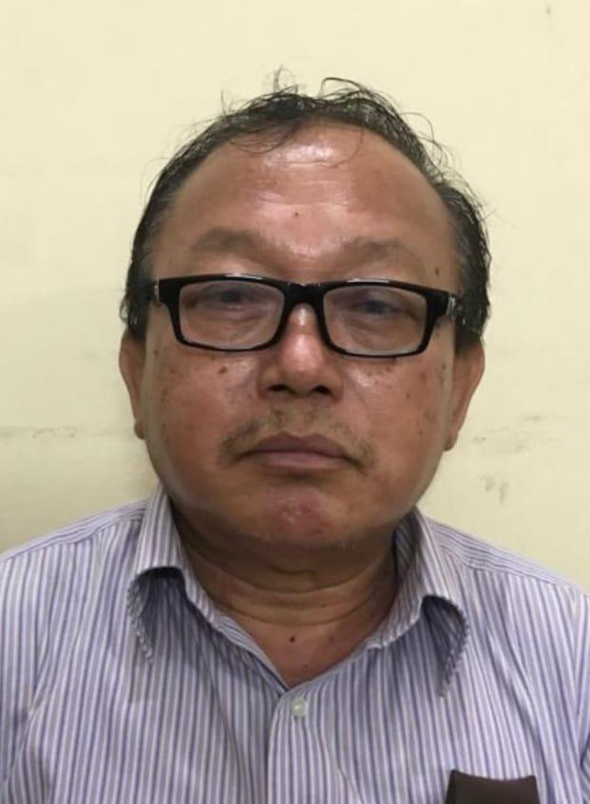 | DR. SUVASH BASU CHAKMA  F/Name: Late. Kiran Kumar Chakma  M/Name: Late. Sansani Chakma  BM & DC Reg. No: 22524  NID: 4624904182814  Cell: 01556773464  Address: M.O (MCH-FP), Mahalchari, Khagrachari  Blood Group:
5 | Voter No  LM-2800005 | DR. JAYA CHAKMA  F/Name: Rajendra Lal Chakma  M/Name: Indira Devi Chakma  BM & DC Reg. No: 43964  NID:  Cell: 01556565202  Address: District Sadar Hospital, Khagrachari  Blood Group: A+
6 | Voter No  LM-2800006 | DR. TUTUL CHAKMA  F/Name: Late. Suresh Chandra Chakma  M/Name: Tohini Chakma  BM & DC Reg. No: 46687  NID: 2924703124889  Cell: 01557198040  Address: College Para, Sadar, Khagrachari  Blood Group: B+
7 | Voter No  LM-2800007 | DR. SANJIB TRIPURA  F/Name: Brajendra Nath Tripura  M/Name: Saralika Tripura  BM & DC Reg. No: 25498  NID:  Cell: 01556533672  Address: Upazilla Health Complex, Panchari, Khagrachari  Blood Group: A+
8 | Voter No  LM-2800008  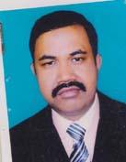 | DR. MITAN CHAKMA  F/Name: Guyana Jouti Chakma  M/Name: Anisha Chakma  BM & DC Reg. No: 43418  NID: 4624904183029  Cell: 01715298247  Address: Mohajan Para, Khagrachari Sadar, Khagrachari  Blood Group: O+
9 | Voter No  LM-2800009  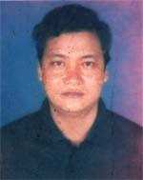 | DR. LAKSHMI DHAN TRIPURA  F/Name: Kumba Ram Tripura  M/Name: Sotibi Tripura  BM & DC Reg. No: 25682  NID: 4624907153014  Cell: 01552432527  Address: SHANTI NAGAR, KHAGRACHARI SADAR, KHAGRACHARI HILL DISTRICT  Blood Group: AB+
10 | Voter No  LM-2800010 | DR. ANUTOSH CHAKMA  F/Name: Sindhu Kumar Chakma  M/Name: Gandha Mala Chakma  BM & DC Reg. No: 44635  NID: 04624901101584  Cell: 01553457605  Address: Diginala Health Complex, Khagrachari  Blood Group: B+
11 | Voter No  LM-2800011  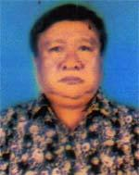 | DR. DIBYA SHEKHAR CHAKMA  F/Name: Late. Sureswar Chakma  M/Name: Late. Ananta Bala Chakma  BM & DC Reg. No: 25672  NID: 4624904182936  Cell: 01556425664  Address: Vill: Mohajan Para, Khagrachari Sadar, Khagrachari  Blood Group: B+
12 | Voter No  LM-2800012  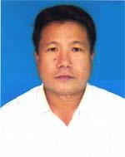 | DR. UTPAL CHAKMA  F/Name: Jagadish Chandra Chakma  M/Name: Roheni Lota Chakma  BM & DC Reg. No: 38778  NID: 4624901105058  Cell: 01820240222  Address: WEST NARAN KHIAYA, PO+PS: KHAGRACHARI, DIST: KHAGRACHARI  Blood Group: B+
13 | Voter No  LM-2800013 | DR. BISWA JYOTI CHAKMA  F/Name: Anil Kumar Chakma  M/Name: Ulupi Chakma  BM & DC Reg. No: 29240  NID: 462490129402  Cell: 01715474375  Address: Vill: Narankhya, PO+PS:- Khagrachari, Dist: Khagrachari  Blood Group: A+
14 | Voter No  LM-2800014 | DR. SAIKAT CHAKMA  F/Name: Kali Mohan Chakma  M/Name: Sagarani Chakma  BM & DC Reg. No: 45138  NID: 2691651195196  Cell: 01715696444  Address: Milanpur, Ward No-07, Khagrachari Sadar  Blood Group: B+
15 | Voter No  LM-2800015  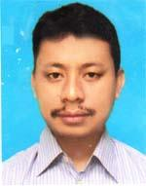 | DR. NAYAN MOY TRIPURA  F/Name: Late- Khagendra Lal Tripura  M/Name: Shanti Bala Tripura  BM & DC Reg. No: 45922  NID: 4624907208765  Cell: 01814160039  Address: MADHUPUR, A.P. BATALIAN ROAD, SADAR, KHAGRACHARI  Blood Group: AB+
16 | Voter No  LM-2800016  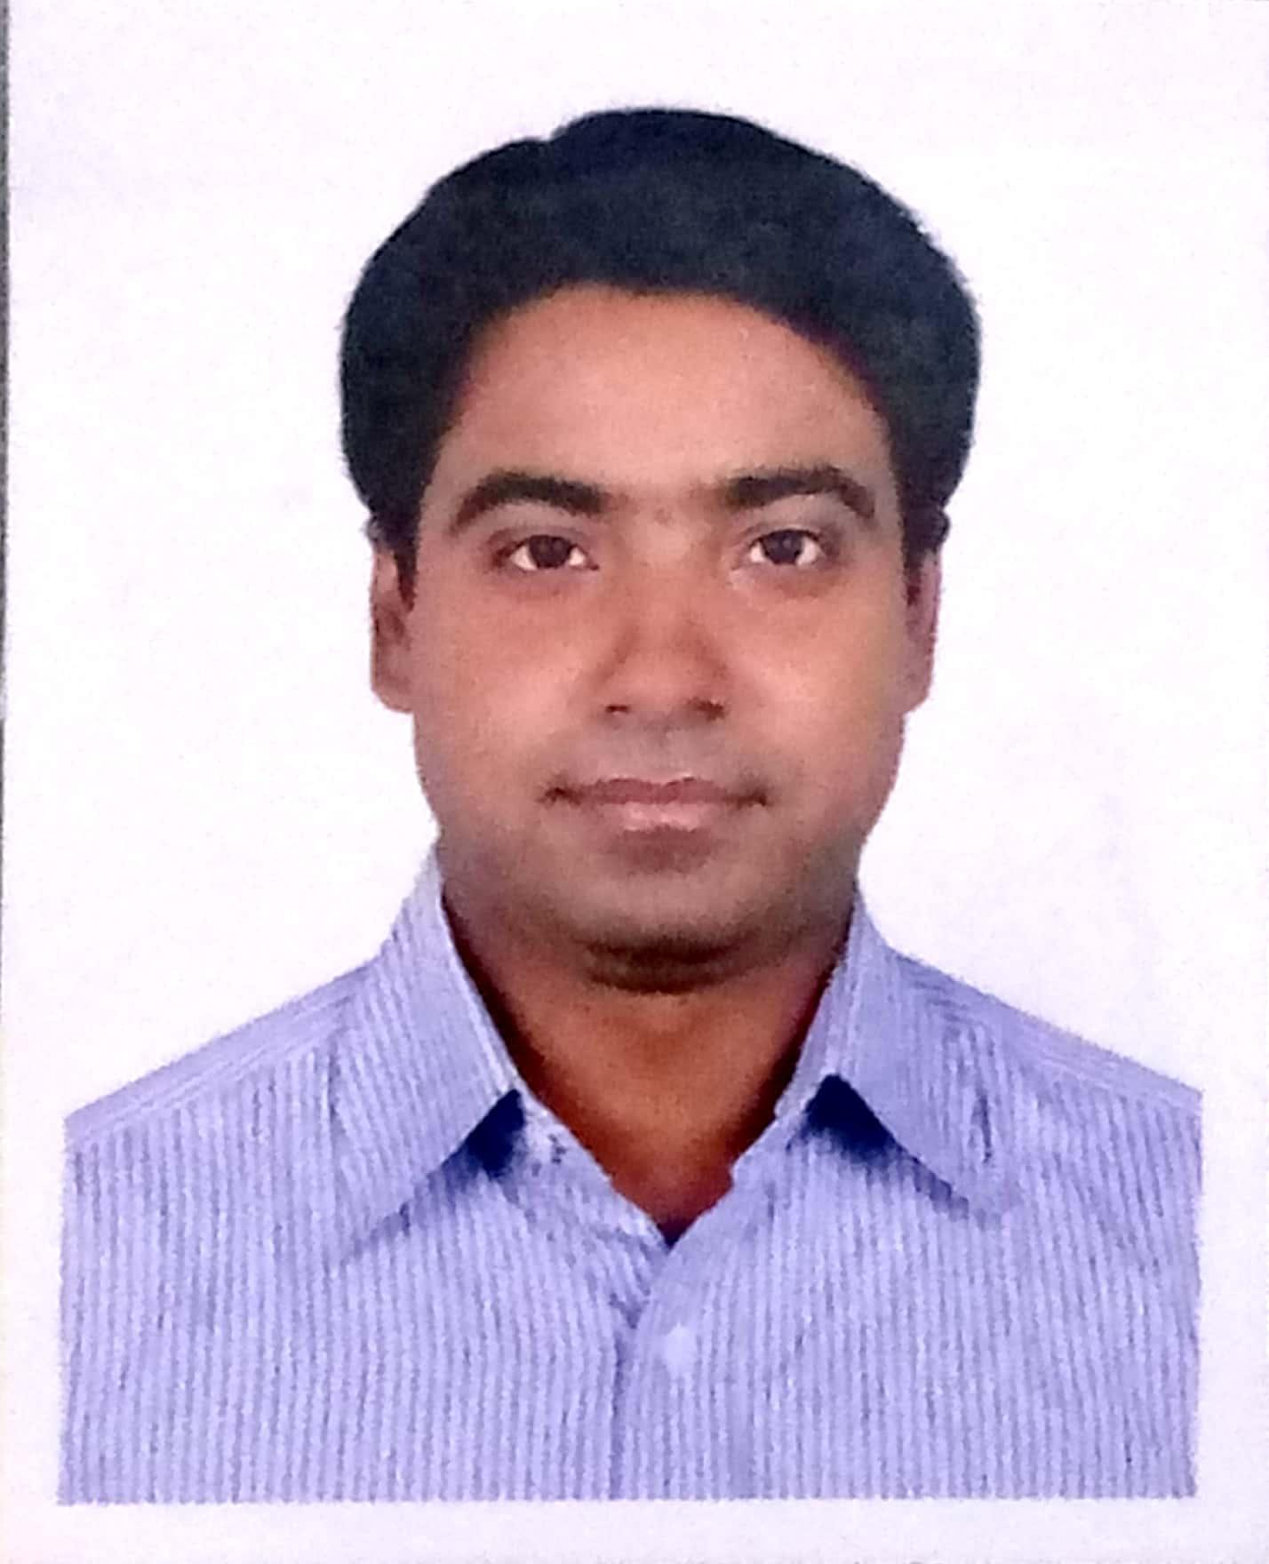 | DR. SHABYASACHI NATH  F/Name: Sudhir Chandra Nath  M/Name: Rina Rani Debi  BM & DC Reg. No: 52618  NID: 19854624902000005  Cell: 01557605058  Address: Flat B1, Welkin's Drubotara, Kobi Nazrul Islam Sarak, Firengee Bazar, Chattogram.  Blood Group: B+
17 | Voter No  LM-2800017 | DR. U CHAW SHWE  F/Name: Kyaw Khoi U  M/Name: Mra. Nwe Pru  BM & DC Reg. No: 16620  NID: 0321405112041  Cell: 01817224149  Address: Office Of Upazilla Health & Family Planning Officer, Sadar Upazilla. Dist: Khagrachari  Blood Group: A+
18 | Voter No  LM-2800018 | DR. ILA CHAKMA  F/Name: Mr. Chitta Ranjan Chakma  M/Name: Mrs. Kanika Chakma  BM & DC Reg. No: 32358  NID: 4624903293257  Cell: 01555038318  Address: West Mohajan Para, KHG, Sadar, KHG Hill District  Blood Group: A+
19 | Voter No  LM-2800019 | DR. RAJARSHI CHAKMA  F/Name: Sadhan Chandra Chakma  M/Name: Kalpona Chakma  BM & DC Reg. No: 52693  NID: 19821028513128592  Cell: 01556541578  Address: MORDENISED DISTRICT SADAR HOSPITAL KHAGRACHARI  Blood Group: B+
20 | Voter No  LM-2800020 | DR. DHANISTA CHAKMA  F/Name: Late. Birajoy Chakma  M/Name: Mrs. Chaya Chakma  BM & DC Reg. No: 57550  NID: 19854627005000001  Cell: 01554471698  Address: Khagrachari Dist. Sadar Hospital, Khagrachari  Blood Group: O+
21 | Voter No  LM-2800021 | DR. SUMEN CHAKMA  F/Name: Sukirti Sadhan Chakma  M/Name: Monika Chakma  BM & DC Reg. No: 7881  NID: 19814624901000007  Cell: 01748851318  Address: Narankhaiya, Khagrachai Sadar, Khagrachari  Blood Group: A+
22 | Voter No  LM-2800022 | DR. SHARWASTI CHAKMA  F/Name: Sugata Chakma  M/Name: Shila Chakma  BM & DC Reg. No: 61009  NID: 19872924703122664  Cell: 01843330681  Address: Khagrachari Sadar, Khagrachari.  Blood Group: B+
23 | Voter No  LM-2800023 | DR. MD. KHAYRUL ALAM  F/Name: Md. Khorshed Alam  M/Name: Jahanara Begum  BM & DC Reg. No: 25694  NID: 4624903293138  Cell: 01553600902  Address: SANTINAGAR, KHAGRACHARI SADAR, KHAGRACHARI  Blood Group: AB+
24 | Voter No  LM-2800024  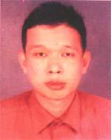 | DR. BIDARSHI CHAKMA  F/Name: Jagadendu Bikash Chakma  M/Name: Bira Bala Chakma  BM & DC Reg. No: 44636  NID: 4624901291457  Cell: 01556770511  Address: UPAZILLA HEALTH COMPLEX, PANCHARI, KHAGRACHARI  Blood Group: B+
25 | Voter No  LM-2800025 | DR. ORVIL CHAKMA  F/Name: Mayadhan Chakma  M/Name: Jagat Janani Chakma  BM & DC Reg. No: 46288  NID: 19802691651195181  Cell: 01728152145  Address: Milanpur, Khagrachari Sadar, Khagrachari  Blood Group: B+
26 | Voter No  LM-2800026 | DR. SAJIB CHAKMA  F/Name: Vaggadon Chakma  M/Name: Choja Marma  BM & DC Reg. No: 75338  NID: 4628009664017  Cell: 01786913834  Address: Aparna Chowdhury Para, Khagrachhari Sadar, Khagrachhri.  Blood Group: O+
27 | Voter No  LM-2800027 | DR. KYACHING HLA MARMA  F/Name: Thoisa Ang Marma  M/Name: Mrasainda Marma  BM & DC Reg. No: 99043  NID: 5052999843  Cell: 01828836508  Address: Matiranga, Khagrachari.  Blood Group: B+
28 | Voter No  LM-2800028 | DR. JHANATH CHAKMA  F/Name: Ratna Kumar Chakma  M/Name: Konika Chakma  BM & DC Reg. No: 66523  NID: 4650919683  Cell: 01749038509  Address: Madhupur, Khagrachari Sadar, Khagrachari.  Blood Group: AB+
29 | Voter No  LM-2800029  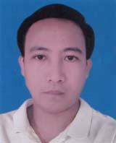 | DR. RIPPLE BAPPI CHAKMA  F/Name: Sonit Ranzan Chakma  M/Name: Meera Chakma  BM & DC Reg. No: 62965  NID: 479851621474  Cell: 01716802488  Address: Modhupur, Khagrachari Sadar, Khagrachari.  Blood Group: O+
30 | Voter No  LM-2800030 | DR. DIGONTA CHAKMA  F/Name: Sulandu Chakma  M/Name: Natuna Chakma  BM & DC Reg. No: 60580  NID: 6900962520  Cell: 01760376056  Address: Khabongpun`ya, Sadar Khagrachari.  Blood Group: AB+
31 | Voter No  LM-2800031 | DR. AGNIBHA CHAKMA TURJA  F/Name: Ananta Bijoy Chakma  M/Name: Sumana Chakma  BM & DC Reg. No: 89951  NID: 5516433116  Cell: 01873785037  Address: Upali Para, Khagrachari Sadar, Khagrachari Hill tract.  Blood Group: AB+
32 | Voter No  LM-2800032 | DR. SUBAL JYOTI CHAKMA  F/Name: Prabhat Chandra Chakma  M/Name: Chunubi Chakma  BM & DC Reg. No: 47356  NID: 6900300366  Cell: 01818233381  Address: Adhunik Zilla Sadar Hospital, Khagrachari Upazilla +Dist- Khagrachari.  Blood Group: AB+
33 | Voter No  LM-2800033 | DR. PURNA JIBAN CHAKMA  F/Name: Lalit Chandra Chakma  M/Name: Shankha Mala Chakma  BM & DC Reg. No: 43162  NID: 4600557617  Cell: 01926005043  Address: Milanpur, Sadar, Khagrachari.  Blood Group: B+
34 | Voter No  LM-2800034 | DR. TIPA CHAKMA  F/Name: Shanta Shil Chakma  M/Name: Bana Rani Chakma  BM & DC Reg. No: 87470  NID: 5969750974  Cell: 01556773257  Address: Mahajan para, Khagrachari Sadar, Khagrachari.  Blood Group: B+
35 | Voter No  LM-2800035 | DR. OPEN CHAKMA  F/Name: Nikhil Priya Chakma  M/Name: Mina Kumari Chakma  BM & DC Reg. No: 54992  NID: 1452291741  Cell: 01556556850  Address: Newzeland Road, Sadar, Khagrachari Hill District.  Blood Group: B+
36 | Voter No  LM-2800036 | DR. NUNU MARMA  F/Name: Odrasai Marma  M/Name: Tatu Marma  BM & DC Reg. No: 73265  NID: 19904616763000022  Cell: 01768198520  Address: Newzeland Road, Pankhaiya Para, Khagrachari Sadar, Dist: Khagrachari.  Blood Group: B+
37 | Voter No  LM-2800037 | DR. UNUCHING MARMA  F/Name: Aungswe Marma  M/Name: Swapna Marma  BM & DC Reg. No: 78640  NID: 9103469053  Cell: 01840866279  Address: Vill: Pankhaiya Para, Khagrachari Sadar Khagrachari, Hill: District.  Blood Group: A+
38 | Voter No  LM-2800038 | DR. MIUCHING MAHAJAN  F/Name: Mongkyaching Marma  M/Name: Dolipru Chowdhury  BM & DC Reg. No: 66133  NID: 8215219547  Cell: 01552544064  Address: Vill: Pankhaiya Para, Post office: Khagrachari Dist: Khagrachari.  Blood Group: B+
39 | Voter No  LM-2800039 | DR. MRACHING MARMA  F/Name: Thaihlamong Marma  M/Name: Ukrai Chowdhury  BM & DC Reg. No: 112234  NID: 9152289436  Cell: 01521220618  Address: Vill: Khangsa Para, Post office: Mahalchari, Upazilla: Mohal Chari, Drst: Khagrachari.  Blood Group: B+
40 | Voter No  LM-2800040 | DR. TANOY TALUKDER  F/Name: Nirapad Talukder  M/Name: Smriti Rekha Talukder  BM & DC Reg. No: 50871  NID: 4614947168966  Cell: 01749150472  Address: Vill: Doyamohan Karbary Para, Post office: Khagrachari sadar, Dist: Khagrachari.  Blood Group: A+
41 | Voter No  LM-2800041  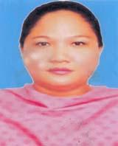 | DR. BEAUTY CHAKMA  F/Name: Chandan Bikash Chakma  M/Name: Kajal Chakma  BM & DC Reg. No: 52826  NID: 2924709173575  Cell: 01715054598  Address: VILL-MILLANPUR, P.O.: KHAGRACHARI, DISTRICT: KHAGRACHARI.  Blood Group: AB+
42 | Voter No  LM-2800042 | DR. MUHAMMAD OMAR FARUK  F/Name: Md. Nurul Alam  M/Name: Nargis Akter  BM & DC Reg. No: 58946  NID: 5100880490  Cell: 01735259451  Address: Vill: Muslim Para PO: Khagrachari PS: Sadar Dist: Khagrachari.  Blood Group: O+
43 | Voter No  LM-2800043  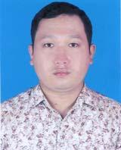 | DR. JEEBOK CHAKMA  F/Name: Nilotpal Chakma  M/Name: Nuru Chakma  BM & DC Reg. No: 71289  NID: 8697994997  Cell: 01778554526  Address: Vill: West Narankhaiya, Khagrachari Sadar, Dist: Khagrachari  Blood Group: B+
44 | Voter No  LM-2800044 | DR. SWEUOKRAI MARMA  F/Name: Mongshathoi Marma  M/Name: Amaya Marma  BM & DC Reg. No: 112681  NID: 3749180059  Cell: 01867269867  Address: Vill: Pankhaiya Para, Khagrachari Sadar, Dist: Khagrachari.  Blood Group: O+
45 | Voter No  LM-2800045 | DR. RA PRUE SAI MARMA  F/Name: Kya Mra Jal Marma  M/Name: Maya Marma  BM & DC Reg. No: 87237  NID: 8698208256  Cell: 01728588726  Address: Vill: Moyourkhil, Upazilla: Manikchari Dist: Khagrachari.  Blood Group: B+
46 | Voter No  LM-2800046 | DR. PRAHAR CHAKMA  F/Name: Bala Bhadra Chakma  M/Name: Toshiba Chakma  BM & DC Reg. No: 111090  NID: 9575984662  Cell: 01554278117  Address: Vill: Sowth Khabongpuriya, Khagrachari Sadar, Dist: Khagrachari.  Blood Group: A+
47 | Voter No  LM-2800047 | DR. CHOWDHURY SHARMIN HAIDER  F/Name: Ali Haider, Chowdhury  M/Name: Mrs. Rashida Khanam  BM & DC Reg. No: 62786  NID: 5958300823  Cell: 01557340292  Address: MA O Sisu Kallan Kendra, Sador Khagrachari.  Blood Group: A+
48 | Voter No  LM-2800048  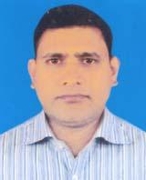 | DR. MOHAMMAD ISMAIL  F/Name: Mohammad Abdus Salam  M/Name: Salma Khatun  BM & DC Reg. No: 50326  NID: 5969926780  Cell: 01673876403  Address: J. Consultant. Sadar Hospital, Khagrachari.  Blood Group: A+
49 | Voter No  LM-2800049 | DR. MILTON TRIPURA  F/Name: Purna Nanda Tripura  M/Name: Dhani Mala Tripura  BM & DC Reg. No: 85897  NID: 1475393656  Cell: 01715423209  Address: Khagrapur, Khagrachari.  Blood Group: A+
50 | Voter No  LM-2800050 | DR. ARNAB CHAKMA  F/Name: Smritendu Bikash Chakma  M/Name: Sreela Talukder  BM & DC Reg. No: 85713  NID: 2397749595  Cell: 01516177419  Address: Vill: Kaylanpur, Khagrachari sadar, Dist: Khagrachari.  Blood Group: O+
51 | Voter No  LM-2800051 | DR. RAJAN TALUKDER  F/Name: Dhiraj Kusum Talukder  M/Name: Manjuri Chakma  BM & DC Reg. No: 71028  NID: 4624901101772  Cell: 01554317886  Address: Vill: Narankhaiya, Post Office+Police Station+ District: Khagrachari  Blood Group: A+
52 | Voter No  LM-2800052 | DR. SHIMUL KAR.  F/Name: Ajit Baran Kar  M/Name: Lucky Rani Kar  BM & DC Reg. No: 81278  NID: 19914617776000207  Cell: 01815512322  Address: Shantinagar Khagrachari Hill Dist: Khagrachari.  Blood Group: O+
53 | Voter No  LM-2800053  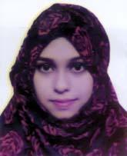 | DR. SALMA SULAIMAN NAZIA  F/Name: Md. Sulaiman  M/Name: Sayeda Yesmin  BM & DC Reg. No: 106311  NID: 1921668057  Cell: 01851356998  Address: Mohalchari Bazar area, Mohalchari Khagrachari.  Blood Group: A+
54 | Voter No  LM-2800054 | DR. MOHAMMAD SHAIFUL ISLAM  F/Name: Mohammad Faridul Alam  M/Name: Mina Akter  BM & DC Reg. No: 78494  NID: 8656845529  Cell: 01758405351  Address: VILL.- MOHALCHARI BAZAR, P.O.: MOHALCHARI, P.S.: MOHALCHARI, DISTRICT: KHAGRACHARI.  Blood Group: O+
55 | Voter No  LM-2800055 | DR. DIPA TRIPURA SHUKLA  F/Name: Kishor Moy Tripura  M/Name: Ritu Tripura  BM & DC Reg. No: 66076  NID: 1481827440  Cell: 01914850285  Address: Adhunik zilla Sadar Hospital Khagrachari.  Blood Group: AB+
56 | Voter No  LM-2800056 | DR. RASEL CHAKMA  F/Name: Santosh Kumer Chakma  M/Name: Sadhana Chakma  BM & DC Reg. No: 60791  NID: 19881022014402300  Cell: 01718216858  Address: 14, Frark Mayiyada Flat-B1, Baelhsah Mia Road, Chattogram.  Blood Group: A+
57 | Voter No  LM-2800057 | DR. KANIZ FATEMA  F/Name: Md. Akbor Hossain  M/Name: Ayesha Begum  BM & DC Reg. No: 94895  NID: 4180903587  Cell: 01686918942  Address: Narikel Bagan, Khagrachari  Blood Group: O+

